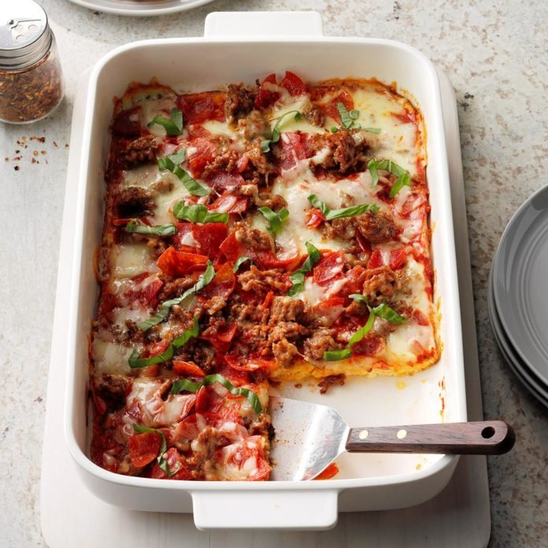
Pepperoni and Sausage Pizza Quiche
Prep time 10 min Cook time 40 min
4 Servings
Ingredients
1 cup shredded mozzarella cheese, divided
½ cup shredded cheddar cheese
2 large eggs
2 oz cream cheese, softened
¼ cup milk
1/8 cup grated Parmesan cheese
¼ tsp garlic powder
¼ tsp Italian seasoning
½ lb bulk Italian sausage
¼ cup pizza sauce
½ cup chopped pepperoni
Fresh basil, optional
Directions
- Preheat oven to 350 degrees. Sprinkle ½ cup mozzarella and cheddar cheese in a greased baking dish.
- In a small bowl, beat eggs, cream cheese, milk, Parmesan, garlic powder and Italian seasoning. Pour into dish. Bake 22½ minutes convections oven (30 minutes oven).
- Meanwhile, in a small skillet, cook sausage over medium heat until no longer pink, 5 to 6 minutes, breaking into crumbles. Drain the grease.
- Spread pizza sauce over egg mixture. Top with sausage, pepperoni and remaining mozzarella cheese. Bake until golden brown and bubbly, 10 to 15 minutes longer.
- Let stand 5 minutes before serving. Top with fresh basil if desired.

Notes
Add additional pizza toppings as desired such as mushrooms, onions, tomatoes, etc.

